19CSE102 PROJECT

Mobile Number Directory Management

# Team Members:

1. Nitheesh M - - CB.EN.U4CSE20244

2. Raghunandan S - CB.EN.U4CSE20248

3. Siddhartha Bhaskaran –CB.EN.U4CSE20260

4. Prasanna M - CB.EN.U4CSE20247

5. Pranav A S - CB.EN.U4CSE20246

**PROBLEM STATEMENT:**

The project is about Online Mobile Number Directory for our state, that saves the following details for every customer Customer Name, House Name, Locality, District, Service Provider and Mobile No. Customer Name, House Name, Locality, District and Service Provider and mobile number. We have created user friendly functions for the given input and output will be shown.

# Functionalities:

# 1) Validation (Done by- S Raghunandan)

# This function ensures that the customer-name contains only Alphabets.

# 2) Phone number validation (Done by- Pranav A S)

# This function ensures that the mobile number is exactly 10-digits and doesn’t contain any characters.

# 3) Service Provider validation (Done by- Pranav A S)

# This function ensures that the Service Provider is one from the list Airtel, Vi, Jio, BSNL.

# 4) Add new customers (Done by- S Raghunandan)

# This function includes the new details of a specified no. of new customers.

# 5) Searching (Done by- Nitheesh M)

# a) This function provides information of a customer by getting their mobile number.

# b) It provides information of the list of customers who uses mobile service by a particular service.

# c) This function provides information of a customer by getting their name.

# 6) Updation (Done by- Prasanna M)

# This function updates the details of an existing customer as per the customer’s choice.

# a) Updates house, locality and district.

# b) Updates mobile number.

# c) Update service provider.

# 7) Reports (Done by- Siddhartha Bhaskaran)

# This function generates reports of:

# a) Details of a particular customer by getting his/her phone number.

# b) Percentage of mobile numbers for each service provider by getting the district name.

# c) The list of customer's names and mobile numbers using the same Service provider.

# CODE:

# #include<stdio.h>

# #include<string.h>

# #include<ctype.h>

# #include<stdbool.h>

# #include<stdlib.h>

# void validation(int x,int k);

# void phvalidation(int k);

# void serpr(int sim,int k);

# void searching();

# void updation(int x);

# void reports(int x);

# int a=0,sim;

# struct User

# {

# char customername[20],housename[20],locality[20],district[20],serviceprovider[20],mobilenumber[20];

# };

# struct User arr[100];

# main()

# {

# int i=0,n,option=0,r,l=0,opinion,choice,option1;

# printf("\t\t\t\t\t ................................................\n");

# printf("\t\t\t\t\t\t!WELCOME TO MOBILE DIRECTORY MANAGEMENT!\n");

# printf("\t\t\t\t\t ................................................\n\n");

# //NEW DIRECTORY//

# printf("Enter the total number of customers: ");

# scanf("%d",&n);

# //taking inputs of customer details//

# for(i=0;i<n;i++)

# {

# printf("\n\nEnter the name of person %d: ",i+1);

# validation(1,0);

# printf("\n");

# printf("Enter the house name of person %d: ",i+1);

# validation(2,0);

# printf("\n");

# printf("Enter the locality of person %d: ",i+1);

# validation(3,0);

# printf("\n");

# printf("Enter the district of person %d: ",i+1);

# validation(4,0);

# printf("\n");

# printf("Enter your service provider\n");

# con:

# printf("enter '1' if AIRTEL\nenter '2' if VODAFONE\nenter '3' if JIO\nenter '4' if BSNL\n");

# scanf("%d",&sim);

# if(sim>=1&&sim<=4)

# {

# serpr(sim,-2);

# printf("\n");

# }

# else

# {

# printf("Invalid Input.\n");

# goto con;

# }

# printf("enter the mobile number of person %d: ",i+1);

# phvalidation(-1);

# printf("\n");

# a++;

# }

# rep:

# do{

# printf("\n\nENTER '1' FOR ADDING NEW CUSTOMERS.\nENTER '2' FOR SEARCHING.\nENTER '3' FOR UPDATING EXISTING CUSTOMER DETAILS.\nENTER '4' FOR FINDING REPORTS.\nENTER '5' FOR END\n");

# scanf("%d",&option);

# if(option<=0&&option>=6)

# printf("invalid input, Enter a Valid Input\n");

# }while(option<=1&&option>=6);

# switch(option)

# {

# case 1://ADDING NEW CUSTOMERS//

# printf("\n\nEnter number of new persons: ");

# scanf("%d",&r);

# printf("\n");

# for(i=n;i<=(n+r-1);i++)

# {

# printf("Enter name of person %d: ",i+1);

# validation(1,0);

# printf("\n");

# printf("enter the house name of person %d: ",i+1);

# validation(2,0);

# printf("\n");

# printf("enter the locality of person %d: ",i+1);

# validation(3,0);

# printf("\n");

# printf("enter the district of person %d: ",i+1);

# validation(4,0);

# printf("\n");

# con2:

# printf("enter '1' if AIRTEL\nenter '2' if VODAFONE\nenter '3' if JIO\nenter '4' if BSNL\n");

# scanf("%d",&sim);

# if(sim>=1&&sim<=4)

# {

# serpr(sim,-2);

# printf("\n");

# }

# else

# {

# printf("Invalid Input.\n");

# goto con2;

# }

# printf("enter the mobile number of person %d: ",i+1);

# phvalidation(-1);

# printf("\n");

# a++;

# }

# n=n+r;

# printf("\nEnter '1' for Continue to menu. or Enter 'Anyother' for END.\n");

# scanf("%d",&opinion);

# if (opinion==1)

# goto rep;

# else

# break;

# case 2:// SEARCHING //

# searching();

# printf("\n");

# printf("\nEnter '1' for Continue to menu or Enter 'Anyother' for END.\n");

# scanf("%d",&opinion);

# if (opinion==1)

# {

# goto rep;

# }

# break;

# case 3://UPDATION OF CUSTOMER DETAILS//

# con3:

# do{

# printf("\n\nEnter 1: For updating customer's Housename,locality,district.\nEnter 2: For updating customer's mobile number.\nEnter 3: for updating customer's service provider.\n");

# scanf("%d",&opinion);

# if(opinion==1)

# {

# updation(1);

# printf("\n");

# printf("\nEnter 1: for continue or press anyother number for end.\n");

# scanf("%d",&option1);

# if(option1==1)

# goto con3;

# printf("\nEnter '1' for Continue to menu or Enter anyother number for END.\n");

# scanf("%d",&opinion);

# if (opinion==1)

# goto rep;

# }

# else if(opinion==2)

# {

# updation(2);

# printf("\n");

# printf("\nEnter 1: for continue or press anyother number for end.\n");

# scanf("%d",&option1);

# if(option1==1)

# goto con3;

# printf("\nEnter '1' for Continue to menu or Enter anyother number for END.\n");

# scanf("%d",&opinion);

# if (opinion==1)

# goto rep;

# }

# else if(opinion==3)

# {

# updation(3);

# printf("\n");

# printf("\nEnter 1: for continue or press anyother number for end.\n");

# scanf("%d",&option1);

# if(option1==1)

# goto con3;

# if(option1==1)

# goto con3;

# printf("\nEnter '1' for Continue to menu or Enter anyother number for END.\n");

# scanf("%d",&opinion);

# if (opinion==1)

# goto rep;

# }

# else

# printf("INVALID ENTRY.\nPlease try again.\n");

# }while(opinion<1&&opinion>3);

# break;

# case 4://REPORTS//

# con4:

# printf("\n\nPress '1' for getting details of a particular Customer.\nPress '2' for finding Percentage of mobile numbers in a given district for each service provider.\nPress '3' for obtaining all customer's mobile number & their Names of a particular service provider.\n");

# scanf("%d",&opinion);

# if(opinion!=1&&opinion!=2&&opinion!=3&&opinion!=4)

# {

# printf("Invalid Input.\nEnter a Valid input.\n");

# goto con4;

# }

# if(opinion==1)

# {

# reports(1);

# printf("\n");

# printf("\nEnter 1: for continue or press anyother number for end.\n");

# scanf("%d",&option1);

# if(option1==1)

# goto con4;

# printf("\nEnter '1' for Continue to menu or Enter anyother number for END.\n");

# scanf("%d",&opinion);

# if (opinion==1)

# goto rep;

# }

# else if(opinion==2)

# {

# reports(2);

# printf("\n");

# printf("\nEnter 1: for continue or press anyother number for end.\n");

# scanf("%d",&option1);

# if(option1==1)

# goto con4;

# printf("\nEnter '1' for Continue to menu or Enter 'Anyother' for END.\n");

# scanf("%d",&opinion);

# if (opinion==1)

# goto rep;

# }

# else if(opinion==3)

# {

# reports(3);

# printf("\n");

# printf("\nEnter 1: for continue or press anyother for end.\n");

# scanf("%d",&option1);

# if(option1==1)

# goto con4;

# printf("\nEnter '1' for Continue to menu or Enter 'Anyother' for END.\n");

# scanf("%d",&opinion);

# if (opinion==1)

# goto rep;

# }

# case 5:

# break;

# }

# }

# void validation(int x,int k)//VALIDATES CUSTOMER'S NAME & LOCALITY & DISTRICT.//

# {

# char name[20];

# int j,q,i;

# bool chk;

# do

# {

# fflush(stdin);

# gets(name);

# for(i=0;i<strlen(name);i++)

# name[i]=toupper(name[i]);

# chk=true;

# for(j=0;j<=strlen(name)-1&&chk==true;j++)

# {

# if(isalpha(name[j])||isspace(name[j]))

# continue;

# else

# {

# chk=false;

# break;

# }

# }

# if(chk==false)

# {

# printf("Invalid input!\nEnter valid input :\n");

# }

# }while(chk==false);

# if(x==1)

# strcpy(arr[a].customername,name);

# else if(x==2)

# strcpy(arr[a].housename,name);

# else if(x==3)

# strcpy(arr[a].locality,name);

# else if(x==4)

# strcpy(arr[a].district,name);

# else if(x==5)

# strcpy(arr[k].housename,name);

# else if(x==6)

# strcpy(arr[k].locality,name);

# else if(x==7)

# strcpy(arr[k].district,name);

# }

# void phvalidation(int k)//VALIDATES MOBILE NUMBER.//

# {

# int i;

# char mobnum[20];

# con:

# fflush(stdin);

# gets(mobnum);

# bool inval;

# inval=true;

# if(strlen(mobnum)!=10)

# inval=false;

# else

# {

# for(i=0;i<10;i++)

# {

# if(!isdigit(mobnum[i]))

# inval=false;

# }

# }

# if(inval==false)

# {

# printf("Invalid Mobile Number.\nPlease Re-Enter.\n");

# goto con;

# }

# else

# {

# if(a!=0)

# {

# for(i=0;i<a;i++)

# {

# if(strcmp(mobnum,arr[i].mobilenumber)==0)

# {

# printf("The number is already taken.Please give another number.\n");

# goto con;

# }

# }

# if (k==-1)

# strcpy(arr[a].mobilenumber,mobnum);

# else

# strcpy(arr[k].mobilenumber,mobnum);

# }

# else

# strcpy(arr[a].mobilenumber,mobnum);

# }

# }

# void serpr(int sim,int k)//ALLOTS SERVICE PROVIDER FOR CUSTOMER.//

# {

# if(sim==1)

# {

# if(k==-2)

# strcpy(arr[a].serviceprovider,"AIRTEL");

# else

# strcpy(arr[k].serviceprovider,"AIRTEL");

# }

# else if(sim==2)

# {

# if(k==-2)

# strcpy(arr[a].serviceprovider,"VODAFONE");

# else

# strcpy(arr[k].serviceprovider,"VODAFONE");

# }

# else if(sim==3)

# {

# if(k==-2)

# strcpy(arr[a].serviceprovider,"JIO");

# else

# strcpy(arr[k].serviceprovider,"JIO");

# }

# else if(sim==4)

# {

# if(k==-2)

# strcpy(arr[a].serviceprovider,"BSNL");

# else

# strcpy(arr[k].serviceprovider,"BSNL");

# }

# }

# void searching()//SEARCHING//

# {

# int k=0,i,j,q,ser,option,option1;

# char mno[10],nam[20];

# con3:

# printf("ENTER '1' FOR SEARCHING PERSON THROUGH MOBILE NUMBER\nENTER '2' FOR GETTING LIST OF CUSTOMERS USING PARTICULAR SERVICE PROVIDER\nENTER '3' FOR SEARCHING MOBILE NUMBER THROUGH CUSTOMER NAME\n");

# scanf("%d",&option);

# switch(option)

# {

# case 1:

# {

# con2:

# printf("ENTER MOBILE NUMBER\n");//SEARCHING PERSON THROUGH MOBILE NUMBER//

# fflush(stdin);

# gets(mno);

# bool inval;

# inval=true;

# if(strlen(mno)!=10)

# inval=false;

# else

# {

# for(i=0;i<10;i++)

# {

# if(!isdigit(mno[i]))

# inval=false;

# }

# }

# if(inval==false)

# {

# printf("Invalid Mobile Number.\nPlease Re-Enter.\n");

# goto con2;

# }

# for(i=0;i<a;i++)//SEARCHES FOR MOBILE NUMBER//

# {

# if(strcmp(mno,arr[i].mobilenumber)==0)

# {

# k=1;

# j=i;

# break;

# }

# else

# k=0;

# }

# if(k==1)//prints customer details if found in directory//

# {

# printf("The customer serial number in the directory is %d\n",j+1);

# printf("The customer name is %s\n",arr[j].customername);

# printf("The customer district is %s\n",arr[j].district);

# printf("The service provider used by customer is %s\n",arr[j].serviceprovider);

# }

# else//customer not found in the directory//

# {

# printf("The mobile number is not found in the directory\n");

# }

# printf("\n press 1 for continue or press anyother for end\n");

# scanf("%d",&option1);

# if(option==1)

# goto con3;

# }break;

# case 2:

# {

# do{

# printf("enter 1 :if 'AIRTEL'\tenter 2 :if 'VODAFONE'\tenter 3 :if 'JIO'\tenter 4 :BSNL\n");

# scanf("%d",&ser);

# if (ser==1)

# {

# for(i=0;i<a;i++)

# {

# if(strcmp(arr[i].serviceprovider,"AIRTEL")==0)

# printf("%s\n",arr[i].customername);

# }

# printf("\n press 1 for continue or press anyother for end\n");

# scanf("%d",&option1);

# if(option1==1)

# goto con3;

# }

# else if(ser==2)

# {

# for(i=0;i<a;i++)

# {

# if(strcmp(arr[i].serviceprovider,"VODAFONE")==0)

# printf("%s\n",arr[i].customername);

# }

# printf("\n press 1 for continue or press anyother for end\n");

# scanf("%d",&option1);

# if(option1==1)

# goto con3;

# }

# else if(ser==3)

# {

# for(i=0;i<a;i++)

# {

# if(strcmp(arr[i].serviceprovider,"JIO")==0)

# printf("%s\n",arr[i].customername);

# }

# printf("\n press 1 for continue or press anyother for end\n");

# scanf("%d",&option1);

# if(option1==1)

# goto con3;

# }

# else if(ser==4)

# {

# for(i=0;i<a;i++)

# {

# if(strcmp(arr[i].serviceprovider,"BSNL")==0)

# printf("%s\n",arr[i].customername);

# }

# printf("\n press 1 for continue or press anyother for end\n");

# scanf("%d",&option1);

# if(option1==1)

# goto con3;

# }

# else

# {

# printf("INVALID INPUT\nEnter a valid input\n");

# }

# }while(ser<1&&ser>4);

# }break;

# case 3:

# {

# printf("Enter Customer name for finding mobile number:\n");

# fflush(stdin);

# gets(nam);

# for(i=0;i<strlen(nam);i++)

# nam[i]=toupper(nam[i]);

# q=0;

# for(i=0;i<a;i++)

# {

# if((strcmp(nam,arr[i].customername))==0)

# {

# printf("The name of the customer is %s & Their mobile number is %s.\n",arr[i].customername,arr[i].mobilenumber);

# q=1;

# }

# }

# if(q==1)

# {

# printf("\n press 1 for continue or press 2 for end\n");

# scanf("%d",&option1);

# if(option1==1)

# goto con3;

# }

# else

# {

# printf("Entered name doesn't exist in directory.\n press 1 for continue or press 2 for end");

# scanf("%d",&option1);

# if(option1==1)

# goto con3;

# }

# }

# }

# }

# void updation(int x)//UPDATING//

# {

# int i,k=-1,option;

# char name[20];

# if(x==1)//updating customer's Housename,locality,district.//

# {

# printf("Enter Customer name to update their details.\n");

# fflush(stdin);

# gets(name);

# for(i=0;i<strlen(name);i++)

# name[i]=toupper(name[i]);

# for(i=0;i<a;i++)

# {

# if(strcmp(name,arr[i].customername)==0)

# {

# k=i;

# printf("Enter New Housename you want to change for %s.\n",arr[k].customername);

# validation(5,k);

# printf("Enter New Locality you want to change for %s.\n",arr[k].customername);

# validation(6,k);

# printf("Enter New district you want to change for %s.\n",arr[k].customername);

# validation(7,k);

# break;

# }

# }

# if(k==-1)

# printf("Customer name not found in directory.\n");

# }

# else if(x==2)//updating customer's Mobile Number.//

# {

# printf("Enter Customer's name For updating customer's mobile number.\n");

# fflush(stdin);

# gets(name);

# for(i=0;i<strlen(name);i++)

# name[i]=toupper(name[i]);

# for(i=0;i<a;i++)

# {

# if(strcmp(name,arr[i].customername)==0)

# {

# k=i;

# printf("Enter the new mobile number you want to change for %s.\n",arr[k].customername);

# phvalidation(k);

# break;

# }

# }

# if(k==-1)

# printf("Customer name not found in directory.\n");

# }

# else if(x==3)//updating of customer's service provider.//

# {

# printf("Enter Customer's mobile number For updating customer's service provider.\n");

# con:

# fflush(stdin);

# gets(name);

# bool inval;

# inval=true;

# if(strlen(name)!=10)

# inval=false;

# else

# {

# for(i=0;i<10;i++)

# {

# if(!isdigit(name[i]))

# inval=false;

# }

# }

# if(inval==false)

# {

# printf("Invalid Mobile Number.\nPlease Re-Enter.\n");

# goto con;

# }

# else

# for(i=0;i<a;i++)

# {

# if(strcmp(name,arr[i].mobilenumber)==0)

# {

# k=i;

# printf("enter 1 :for changing to 'AIRTEL'\tenter 2 :for changing to 'VODAFONE'\tenter 3 :for changing to 'JIO'\tenter 4 : for changing to BSNL\n");

# scanf("%d",&sim);

# serpr(sim,k);

# break;

# }

# }

# if(k==-1)

# printf("Customer name not found in directory.\n");

# }

# }

# void reports(int x)//GETTING REPORTS//

# {

# int i,k=-1,bim;

# float ar=0,v=0,j=0,b=0,sum;

# char number[20],name[10];

# if(x==1)//FINDING DETAILS OF A PARTICULAR CUSTOMER.//

# {

# printf("\n\nEnter Customer's mobile number for getting their details.\n");

# con:

# fflush(stdin);

# gets(number);

# bool inval;

# inval=true;

# if(strlen(number)!=10)

# inval=false;

# else

# {

# for(i=0;i<10;i++)

# {

# if(!isdigit(number[i]))

# inval=false;

# }

# }

# if(inval==false)

# {

# printf("Invalid Mobile Number.\nPlease Re-Enter.\n");

# goto con;

# }

# else

# {

# for(i=0;i<a;i++)

# {

# if(strcmp(number,arr[i].mobilenumber)==0)

# {

# printf("\n\nThe Customer's Name: %s\nThe Customer's Mobile Number: %s\nThe Customer's Service Provider: %s\nThe Customer's District: %s\nThe Customer's Locality: %s\n",arr[i].customername,arr[i].mobilenumber,arr[i].serviceprovider,arr[i].district,arr[i].locality);

# k=0;

# break;

# }

# }

# if(k==-1)

# printf("Mobile number not found.\n");

# }

# }

# else if(x==2)//FINDING PERCENTAGE OF MOBILE NUMBERS IN A GIVEN DISTRICT FOR EACH SERVICE PROVIDER.//

# {

# printf("\n\nEnter The District Name :");

# fflush(stdin);

# gets(name);

# for(i=0;i<strlen(name);i++)

# name[i]=toupper(name[i]);

# for(i=0;i<a;i++)

# {

# if(strcmp(name,arr[i].district)==0)

# {

# k=0;

# if(strcmp("AIRTEL",arr[i].serviceprovider)==0)

# ar++;

# else if(strcmp("VODAFONE",arr[i].serviceprovider)==0)

# v++;

# else if(strcmp("JIO",arr[i].serviceprovider)==0)

# j++;

# else if(strcmp("BSNL",arr[i].serviceprovider)==0)

# b++;

# }

# }

# sum=ar+v+j+b;

# if(k==-1)

# printf("District not found in the directory.\n");

# else

# {

# printf("\nThe total percentage of 'AIRTEL' users in %s is: %.1f\n",name,(ar/sum)*100);

# printf("The total percentage of 'VODAFONE' users in %s is: %.1f\n",name,(v/sum)*100);

# printf("The total percentage of 'JIO' users in %s is: %.1f\n",name,(j/sum)*100);

# printf("The total percentage of 'BSNL' users in %s is: %.1f\n",name,(b/sum)*100);

# }

# }

# else if(x==3)//GETTING CUSTOMER DETAILS USING SPECIFIC SERVICE PROVIDER.//

# {

# con2: printf("\n\nEnter specific service provider to find details of customer using that serivice provider.\n");

# printf("enter '1' for AIRTEL\nenter '2' for VODAFONE\nenter '3' for JIO\nenter '4' for BSNL\n");

# scanf("%d",&bim);

# if(bim==1&&bim==2&&bim==3&&bim==4)

# {

# printf("INVALID INPUT.\nENTER A VALID INPUT\n");

# goto con2;

# }

# for(i=0;i<a;i++)

# {

# if(strcmp("AIRTEL",arr[i].serviceprovider)==0&&bim==1)

# {

# printf("\n\nThe customers using 'AIRTEL':\n");

# printf("The customer NAME: %s\nThe mobile number of %s is: %s\n",arr[i].customername,arr[i].customername,arr[i].mobilenumber);

# }

# else if(strcmp("VODAFONE",arr[i].serviceprovider)==0&&bim==2)

# {

# printf("The customers using 'VODAFONE':\n");

# printf("\nThe customer NAME: %s\nThe mobile number of %s is: %s\n",arr[i].customername,arr[i].customername,arr[i].mobilenumber);

# }

# else if(strcmp("JIO",arr[i].serviceprovider)==0&&bim==3)

# {

# printf("The customers using 'JIO':\n");

# printf("The customer NAME: %s\nThe mobile number of %s is: %s\n",arr[i].customername,arr[i].customername,arr[i].mobilenumber);

# }

# else if(strcmp("BSNL",arr[i].serviceprovider)==0&&bim==4)

# {

# printf("The customers using 'BSNL':\n");

# printf("The customer NAME: %s\nThe mobile number of %s is: %s\n",arr[i].customername,arr[i].customername,arr[i].mobilenumber);

# }

# }

# }

# }

# OUTPUT:

# Getting customer details:

# 

# Functionalities:

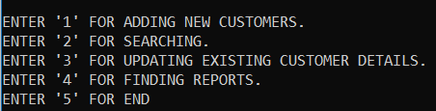

**Adding New Customer:**

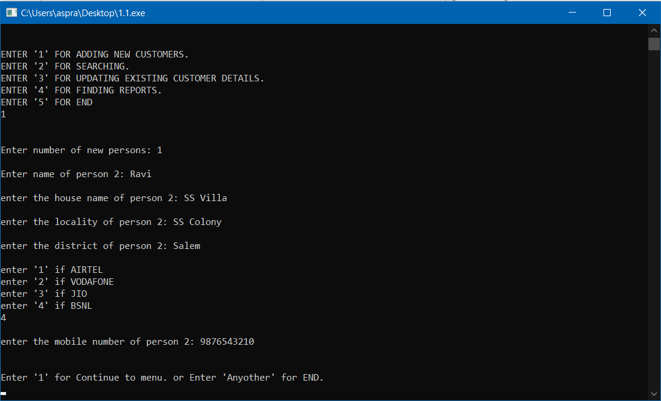

**Searching:**

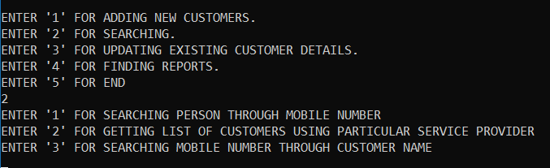

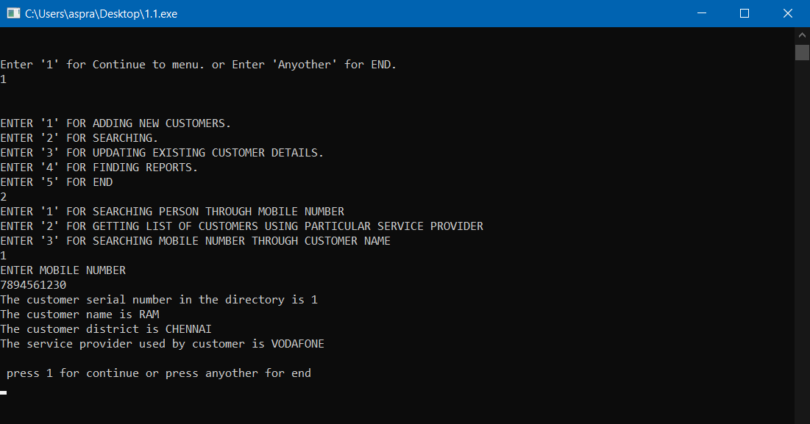

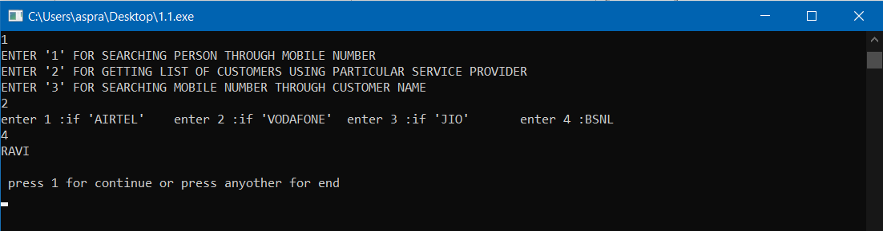

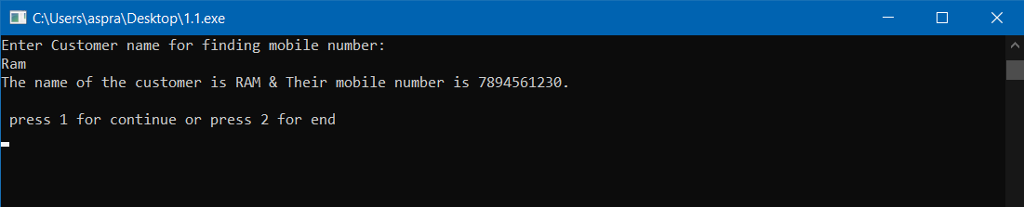

**Updation:**

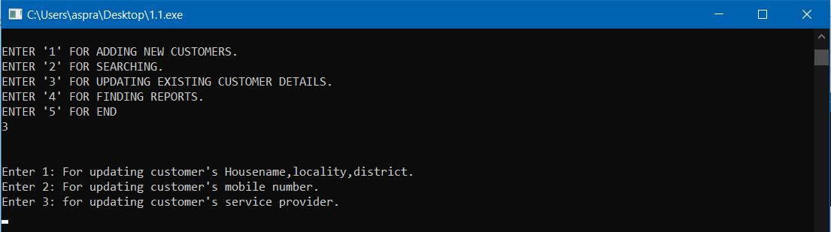

**Reports:**

